Phishing Using Zphisher and URL Masking with Facad1ng

This document provides, step-by-step guide on how to perform phishing simulations using **Zphisher** and enhance URL masking using the **Facad1ng** framework within a Kali Linux environment. These steps are intended strictly for ethical hacking, cybersecurity research, and authorized penetration testing.

1. Phishing Simulation Using Zphisher

### **Prerequisites**
- Kali Linux virtual machine
- Root access
- Internet connectivity

### **Steps**

1. **Open Terminal**
```
sudo su
```

2. **Clone the Zphisher Repository**
```
git clone https://github.com/htr-tech/zphisher.git
```

3. **Navigate to the Zphisher Directory**
```
cd zphisher
```

4. **Launch Zphisher**
```
bash ./zphisher.sh
```

5. **Select a Phishing Template**
- Choose the application or website you want to simulate (e.g., Facebook, Instagram, Gmail).

6. **Select Tunneling Option**
- Choose **Cloudflare** for stable, secure URL tunneling.

7. **Enable URL Masking**
- Select **Yes** when prompted for URL masking.

### **Alternative Method**
You can download Zphisher-generated files to your local machine and host them manually:
- Locate the generated `index.html` or phishing template.
- Upload it to a web server directory such as `/var/www/html`.
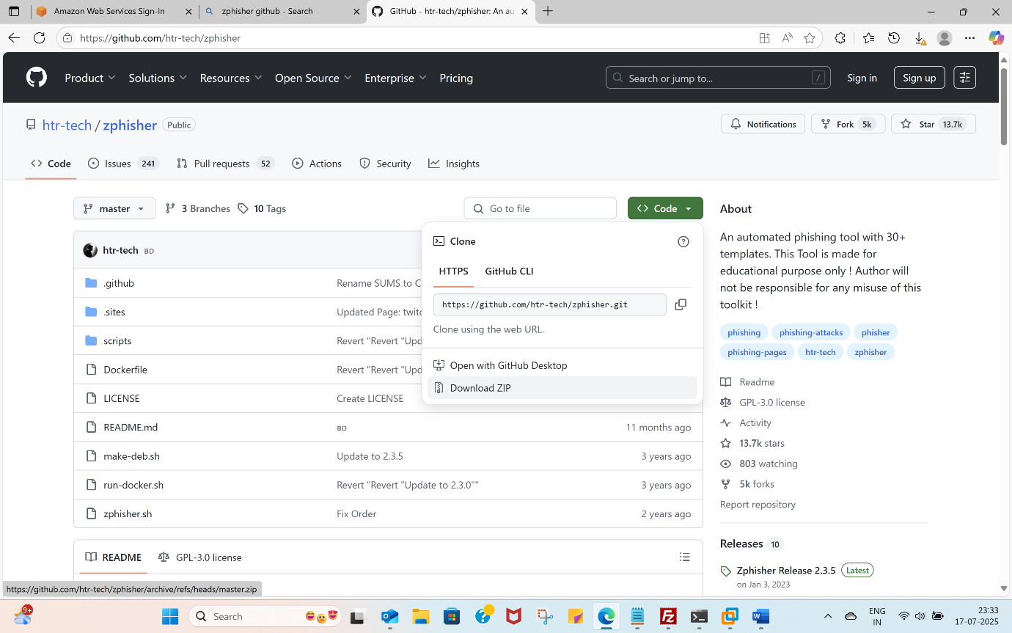

2. URL Masking Using Facad1ng

**Facad1ng** is an open-source URL masking tool that helps make phishing simulation URLs appear more legitimate for cybersecurity awareness training.

### **Steps to Set Up Facad1ng**

1. **Open Terminal**
```
sudo su
```

2. **Clone the Facad1ng Repository**
```
git clone https://github.com/spyboy-productions/Facad1ng.git
```

3. **Navigate to the Directory**
```
cd Facad1ng
```

4. **Update the System**
```
sudo apt-get update && sudo apt-get upgrade -y
```

5. **Create and Activate a Virtual Environment**
```
python3 -m venv .venv
source .venv/bin/activate
```

6. **Install Dependencies**
```
pip3 install -r requirement.txt
```

7. **Run Facad1ng**
```
python3 Facad1ng.py
```
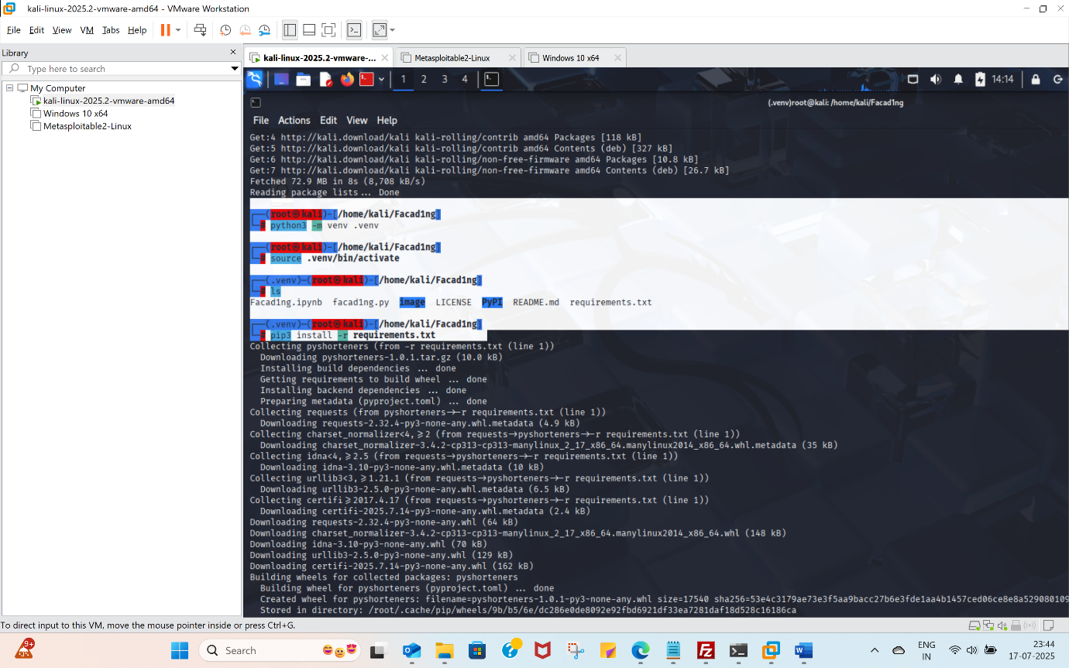
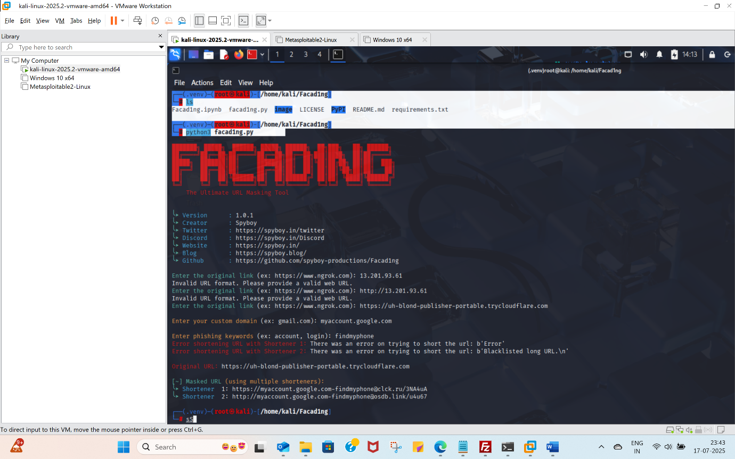
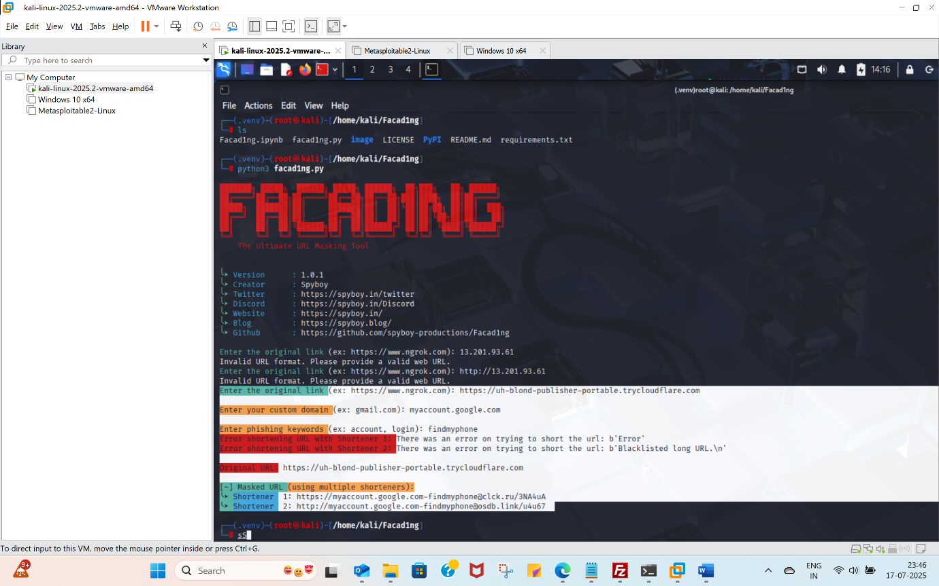
### **Input Requirements**
- **Original URL:** The Cloudflare or tunneling URL generated by Zphisher.
- **Custom Domain or Keyword:** A user-selected domain or phrase to create a more credible-looking masked URL.

**Important Ethical Notice**
These tools must **only** be used:
- With prior authorization
- For security testing
- For cybersecurity training
- In controlled lab environments

Unauthorized phishing is illegal and punishable under cybersecurity laws.

